Unfortunately, we are now facing our second celebration of Holy Week and Easter under lockdown. This is disappointing for all of us but it does not inhibit us from being united as a parish in prayer. Fortunately, we will be able to livestream our ceremonies on the Balyna Parish YouTube Channel. As Michal, our videographer, is extraordinarily busy with the many communities who have asked him to livestream ceremonies, our timetable has to concur with his possibilities. Therefore, our ceremonies will be held at the following times:
Holy Week and Easter Ceremonies 2021
  - Palm Sunday,
  - 28 March 2021

Balyna Parish Newsletter

St Mary’s, Broadford

St Patrick’s, Johnstownbridge

St Brigid’s, Clogherinkoe
Holy Thursday Mass of the Lord’s Supper: 5.00pm
Child Safeguarding Representatives

Patricia Mooney 087 2344252.
Marian O’ Gorman 086 8265381.
Marie McCabe 087 6567660.
Rose Miggan 087 6394816.
Evelyn Bonner 087 6141981.
Chris Barea 086 0602503.

Good Friday Celebration of the Passion: 3.00pm
Holy Saturday Vigil Mass: 4.00pm
Easter Sunday Morning Mass: 9.30 am
As always, we thank you for the unity in prayer that comes about as we tune in together for these ceremonies.

Palms
Palms will be blessed at Mass this morning. Simply take a branch of Yew tree and hold it as you pray with us at Mass.

Trocaire Boxes
Chrism Mass 2021
This year’s Chrism Mass can be viewed via the Kildare and Leighlin Facebook page and iCatholic livestream. We are delighted to be able to share greetings from our parishes from 7:10pm, with Mass beginning at 7:30 pm. Please join Bishop Denis for this celebration of the diocesan family.

These can be brought to the church during the permanences. Please do not leave any Trocaire boxes in the church outside of the permanence times. Alternatively, they can be returned to the Presbytery or the Office.

Easter Collection
Many thanks for the generous support at the Lenten station. An envelope is included in the boxes of envelopes for the Easter Collection. There are also some envelopes in the churches which can be used for this. I am genuinely grateful for your outstanding generosity!

Confirmation and Holy Communion
There is still no clarity around dates for these ceremonies. We simply have to adapt a “wait and see” attitude. Each Sunday, at the end of our broadcast Mass, we will have a moment of catechesis for the Confirmation and Communion candidates and we look forward to their greater participation in the life of the Parish.

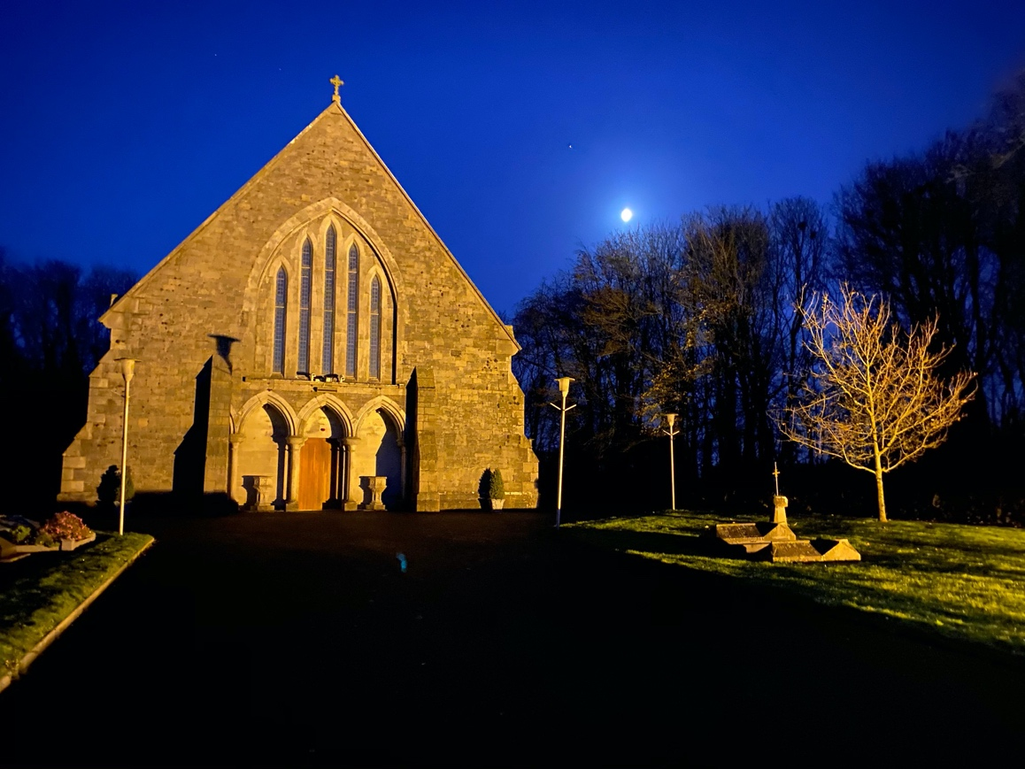
Wintertime image of St Mary’s Church, Broadford.

Anniversaries and Intentions
Jack Martin, Sligo.
Terry and Margaret Groome, Tanderagee.
Ted, Conn, Kieran, Bernie, Austin, Jimmy Groome and Paddy Gorry, Broadford.
Jack Kavanagh, Garrisker (36th anniversary) and his wife, Eileen (9th anniversary).
John Dunne, Kildangan.
Reggie Johnstone, Thomastown.
We also pray for Helen Leonard, late of The Glebe, Johnstownbridge, who died recently.

Permanences
The permanences will be held in each church at the following times this week:
Sunday, 2.00-5.00pm: Broadford
Monday, 4.00-6.00pm: Johnstownbridge
Tuesday, 4.00-6.00pm Clogherinkoe.
During this time, either Fr Sean or someone else will be available in the church. People can return envelopes or obtain Mass cards. Please be mindful always of social distancing norms and keep all contacts safe! Masks should be worn and contacts kept to a minimum.

Contact
Please use e-mail or the telephone to make contact at present as much as possible. Phone contact should be between 10.00 am and noon from Monday to Thursday (046 9551203). The e-mail addresses are as follows:
Office: balynaparish2020@gmail.com
Fr Sean: ppbalyna@gmail.com

